Read chapter 5 in your textbook. The following review questions should help guide your reading. **Points possible 36**

For each question, you should give a correct answer (as best you know it) or provide an intelligent question regarding the reading that applies to this question and explains why you could not answer the question. (Please note that "I didn't understand any of this" isn't a question, isn't intelligent, and has spelling and grammar errors. It will receive 0 points.)

**Make sure to show your work. Answer the questions using your own words and understandings on the chapter materials.**

1. (2 points) R8 True or false: When an OSPF route sends its link state information, it is sent only to those nodes directly attached neighbors. Explain.
   1. True. It advertises to all other routers in entire AS.
2. (2 points) R10. Define and contrast the following terms: subnet, prefix, and BGP route.
   1. Subnet – a logical partition of an IP network into multiple, smaller network segments
   2. Prefix – aggregation of IP addresses that sets a certain number of bits to a specific track
   3. BGP route – A standardized protocol designated to exchange routing information across autonomous systems(AS).
3. (3 points) R15. Suppose you wanted to implement a new routing protocol in the SDN control plane. At which layer would you implement that protocol? Explain.
   1. It would be best to implement the new protocol at the Northbound interface because it is meant for better communication.
4. (10points) P3. Consider the following network. With the indicated link costs, use Dijkstra’s shortest-path algorithm to compute the shortest path from x to all network nodes. Show how the algorithm works by computing a table similar to Table 5.1 .

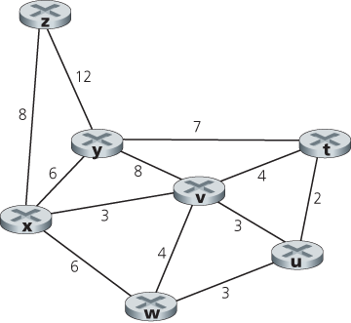

|  |  |  |  |  |  |  |  |
| --- | --- | --- | --- | --- | --- | --- | --- |
| *Step* | *N’* | *D(t),p(t)* | *D(u),p(u)* | *D(v),p(v)* | *D(w),p(w)* | *D(y),p(y)* | *D(z),p(z)* |
| 0 | x | ∞ | ∞ | 3,x | 6,x | 6,x | 8,x |
| 1 | xv | 7,v | 6,v | 3,x | 6,x | 6,x | 8,x |
| 2 | xvu | 7,v | 6,v | 3,x | 6,x | 6,x | 8,x |
| 3 | xvuw | 7,v | 6,v | 3,x | 6,x | 6,x | 8,x |
| 4 | xvuwy | 7,v | 6,v | 3,x | 6,x | 6,x | 8,x |
| 5 | xvuwyt | 7,v | 6,v | 3,x | 6,x | 6,x | 8,x |
| 6 | xvuwytz | 7,v | 6,v | 3,x | 6,x | 6,x | 8,x |

1. (10 points) P5. Consider the network shown below, and assume that each node initially knows the costs to each of its neighbors. Consider the distance-vector algorithm and show the distance table entries at node z. Use the partially completed table to guide you.

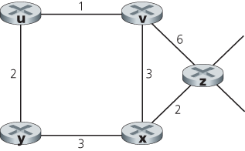

Cost to

u v x y z

v ∞ ∞ ∞ ∞ ∞

From x ∞ ∞ ∞ ∞ ∞

z ∞ 6 2 ∞ 0

Cost to

u v x y z

v 1 0 3 ∞ 6

From x ∞ 3 0 3 2

z ∞ 5 2 ∞ 0

Cost to

u v x y z

v 1 0 3 3 5

From x 4 3 0 3 2

z ∞ 5 2 5 0

Cost to

u v x y z

v 1 0 3 3 5

From x 4 3 0 3 2

z 7 5 2 5 0

1. (2 points) P9. Consider the count-to-infinity problem in the distance vector routing. Will the count-to-infinity problem occur if we decrease the cost of a link? Why? How about if we connect two nodes which do not have a link?
   1. The count to infinity problem will not occur if we decrease the cost because it will update the new cost. If we connect 2 nodes that do not have a link it will assign anamount of time to those two nodes which is less than infinity or the cost of the new link.
2. (2 points) P12. Describe how loops in paths can be detected in BGP.
   1. The router will verify all AS values that come its way and if it runs across its own number, it will discard the advertisement to prevent the looping
3. (5 points) P14. Consider the network shown below. Suppose AS3 and AS2 are running OSPF for their intra-AS routing protocol. Suppose AS1 and AS4 are running RIP for their intra-AS routing protocol. Suppose eBGP and iBGP are used for the inter-AS routing protocol. Initially suppose there is no physical link between AS2 and AS4.
   1. Router 3c learns about prefix x from which routing protocol: OSPF, RIP, eBGP, or iBGP?
      1. eGBP
   2. Router 3a learns about x from which routing protocol?
      1. OSPF
   3. Router 1c learns about x from which routing protocol?
      1. eGBP
   4. Router 1d learns about x from which routing protocol
      1. RIP

